User’s Manual - Group 2

Introduction:
Welcome to our digital Scrabble-style game!
This application brings the classic word game Scrabble experience into a time-based single-player format. This user’s manual provides a step-by-step guide on how to install, launch, and use the software.

1) Overview
This software is a single-player word game where players will build words using letter tiles across a board. A player earns points based on word length and placement and points are accumulated to reach a target score before the timer runs out.

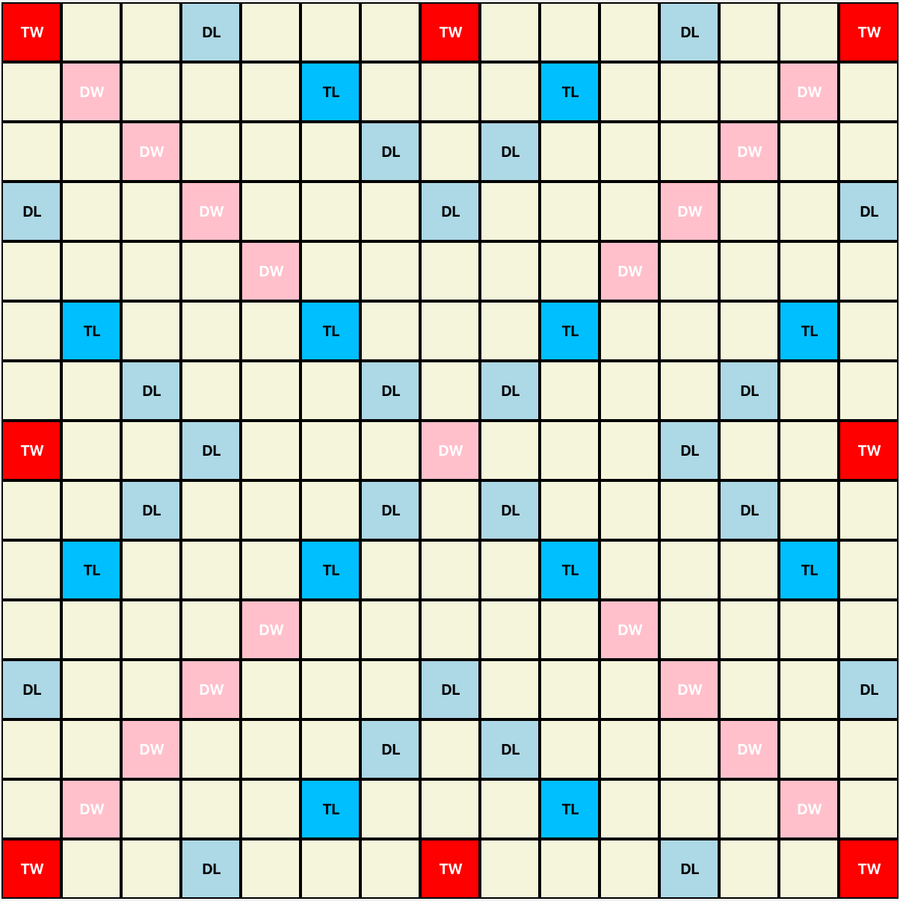
2) Understanding the Interface

2.1) Game Board
- 15 x 15 grid board
- Players will place words here.

2.2) Tile Rack
- The tile rack is located below the Game Board, at the bottom of the screen.
- Displays 7 letter tiles for a player to place on the board.
- Letter tiles are used by the player to form words.
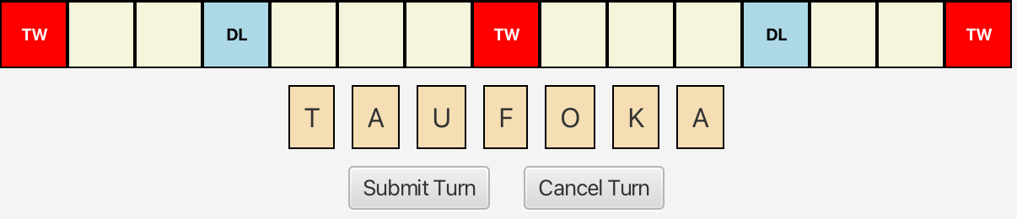

2.3) Score Display / Timer

- The Score Display and Timer are located above the Game Board, at the top of the screen.
- Score Display
  - Displays player’s current score.
  - Begins at 0 and increases as the player accumulates points.
- Timer
  - Displays player’s remaining time
  - Begins at 5 minutes (300 seconds) and counts down.

2.4) Control Buttons

- Submit Turn Button:
  - Confirms player’s move.
  - Adds points and Calculates score per turn.
- Cancel Turn Button:
  - Removes all tiles placed during current turn and returns tiles to player’s tile rack.


3) How to Play

Key Terms:

Tile | A letter with a point value used to form words
Rack | Set of 7 tiles available to the player
Board | 15 x 15 grid where tiles are placed to form words
Turn | Single move where the player places one or more tiles on the board.
‘Invalid Move’ | Player’s move does not follow the game rules; move is rejected
‘Game Won’ | Player reaches/ exceeds target score before the timer runs out
‘Game Lost’ | Player does not reach target score before the timer runs out

3.1) Starting the Game

- Launch the application.
- Player begins with:
  - Score = 0
  - Time = 5 minutes (300 seconds)
  - Target Score = 100

Seven (7) random letter tiles are placed in the player’s tile rack each game. Players can drag and drop these tiles onto the board to create a word and submit the turn.

To place a tile on the board:

- Click and hold a tile from the tile rack.
- Drag the tile to a square space on the board.
- Release to place the tile down.

**A player may place more than one tile per turn**

3.2) Game Rules

- Tiles must be placed on the board in a straight line (horizontal / vertical)
- Tiles must be placed to form a connected word
- The first word placed must be placed through the center on the board
- Tiles cannot be placed over existing tiles
- Words created must be valid English words
~ Otherwise, the game will reject the player’s move. Cancel the turn and try again. ~

Game WON if players can reach or exceed the target score (100 points) within the time limit.

Game LOST if players do not reach or exceed the target score (100 points) before the timer reaches 00:00.

4) Scoring

- Each letter tile in this game has a point value.
- Some squares on the board have special features that can increase the player’s score when a tile is placed there.
- Scores are automatically calculated when the player submits a turn.

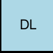 | Double Letter (DL)  Doubles the point value of one letter
 | Triple Letter (TL)  Triples the point value of one letter
 | Double Word (DW)  Doubles the score for the entire word
 | Triple Word (TW)  Triples the score for the entire word

